**User Manual**

**jWebSocket**

**Python client library**

**Author name?**

**Version history?**

# Characteristics of the solution

# The Python Client Library enables the communication between a python client and the jWebSocket server which is responsible for managing the connection and transfer files between them. The information travels over the two-way communication WebSocket protocol achieving greater application performance (compared to what?).

# Main functionalities

The Python Client Library provides the following functionality:

1. Start and End the connection to the server jWebSocket.
2. Send and receive information with the server jWebSocket. Low level or token based as well?

Any developer or institution that implements Python apps and wants to develop desktop applications using the jWebSocket framework can use the library as it is very easy to use.

# Problems to be solved

|  |  |
| --- | --- |
| **Problem** | **Contributions of the solution** |
| Low productivity and reliability of real-time applications with the Python programming. | A Python Client Library has two customers a low level that can be used for any application with any framework and other high-level client to communicate with the jWebsocket framework. Is that the Token level? What is the benefit compared to the problem? |

# Glossary of Terms

**Real-time Web:** Allows the client to receive messages from the server without a prior request and end users to receive updates at the same time.

**WebSocket:** Technology that provides a bidirectional and full-duplex communication channel over a single TCP socket. This protocol solves the limitations of HTTP, by establishing a full-duplex communication (TCP) between the client and server, replacing the half-duplex communication (HTTP). Is strongly reduces the network traffic. For the WebSocket communication between the client and the server, there is only sending 2 bytes, eliminating the HTTP headers.

**Full-Duplex:** Quality of the elements that allow the input and output of data simultaneously.

**jWebSocket:** Is a new technology aiming to develop WebSocket based applications that provide high levels of speed, scalability, security and real-time work.

**Client library:** It is a set of programming interfaces used to develop client applications.The client libraries provide generic building blocks of distributed client applications.

# Model of the solution

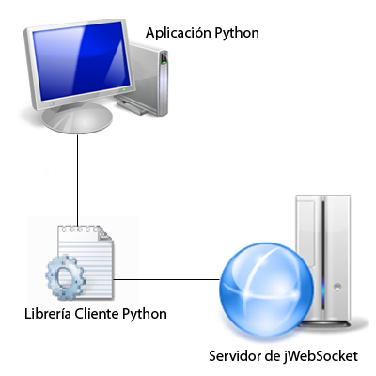

Can you please provide an image with English terms?

The Python client library is responsible for communicating to the client application to server jWebSocket.

# Requirements for the Use

 For proper operation of the Client Library Python equal or later Version 2.5 is required.

# Main Roles

System User: You can perform all actions provided by the client library.

# Configurations of the solution

Python is a dynamic language and functional unlike java and other languages ​​with only a few lines can the user can solve an infinite number of problems. This is one of the reasons that often make Python developers don’t like configuration files and unreadable (??). To develop this principle has been followed this rule, if a line can only change the world needed to Python XML or YAML 1000. I don’t understand this sentence, can you please give a sentence about XML or YAML for the readers who don’t know about that.